PYTHON PROGRAMMING INTERNSHIP – TASK 2

- STUDENT RECORD MANAGEMENT SYSTEM

Submitted by:
Palak Mishra

Technology: Python
IDE: Visual Studio Code
1. Introduction
The Student Record Management System is a command-line application developed using Python. The application is designed to maintain student information in a simple and organized manner.The system allows the user to add, view, search, update, and delete student records. Student information is stored in a CSV file so that records can be maintained between program executions.This project applies Python programming concepts such as object-oriented programming, file handling, exception handling, input validation, and modular project organization
2. Problem Statement
Maintaining student records manually can be time-consuming and difficult to manage. Records may also be lost or become difficult to update.The purpose of this project is to develop a simple command-line application that provides basic operations for managing student records and stores the information using a CSV file.
3. Objectives
• Add new student records.
• View existing student records.
• Search for a student using roll number.
• Update existing student information.
• Delete student records.
• Store student data in a CSV file.
• Handle invalid input using exception handling.
4. Technologies Used
• Programming Language: Python
• IDE: Visual Studio Code
• Storage: CSV file
• Version Control: Git and GitHub
• Documentation: Markdown

5. Project Features
The Student Record Management System provides the following features:
1. Add Student – Adds a new student record.
2. View Students – Displays the available student records.
3. Search Student – Searches for a student using the roll number.
4. Update Student – Modifies an existing student record.
5. Delete Student – Removes a student record.
6. Exit – Closes the application.
6. Design and Implementation
The project uses an object-oriented approach. Student information is represented using a Student class containing attributes such as roll number, name, course, and marks.The application provides a menu-driven interface through which the user selects the required operation. Student records are loaded from and saved to a CSV file.Input validation and exception handling are used to reduce errors caused by invalid user input.
7. Project Structure Figure
1: Project folder structure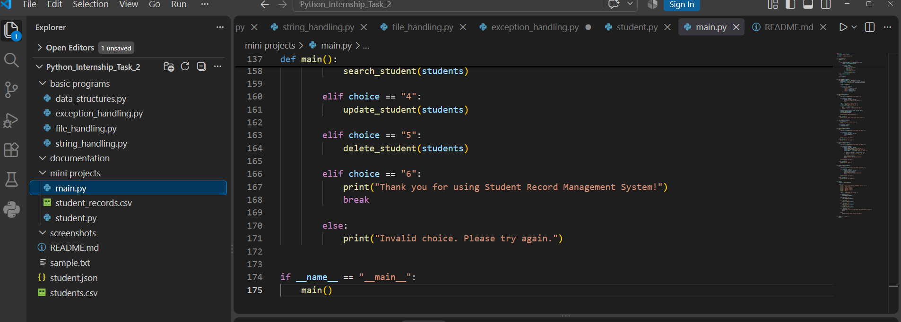
8. Testing and Results
The application was tested by performing the major operations available in the menu.
• Add Student: Successfully added student records.
• View Students: Successfully displayed stored records.
• Search Student: Successfully searched records using roll number.
• Update Student: Successfully modified existing records.
• Delete Student: Successfully removed records.
• CSV Storage: Student records were stored in the CSV file.
• Exception Handling: Invalid input was handled without terminating the application unexpectedly.
Figure 2: Main application menu
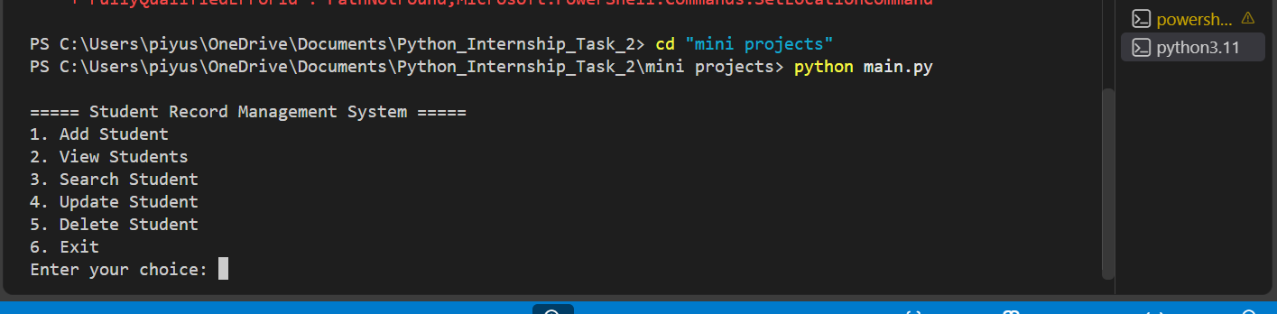
Figure 3: Adding and viewing a student
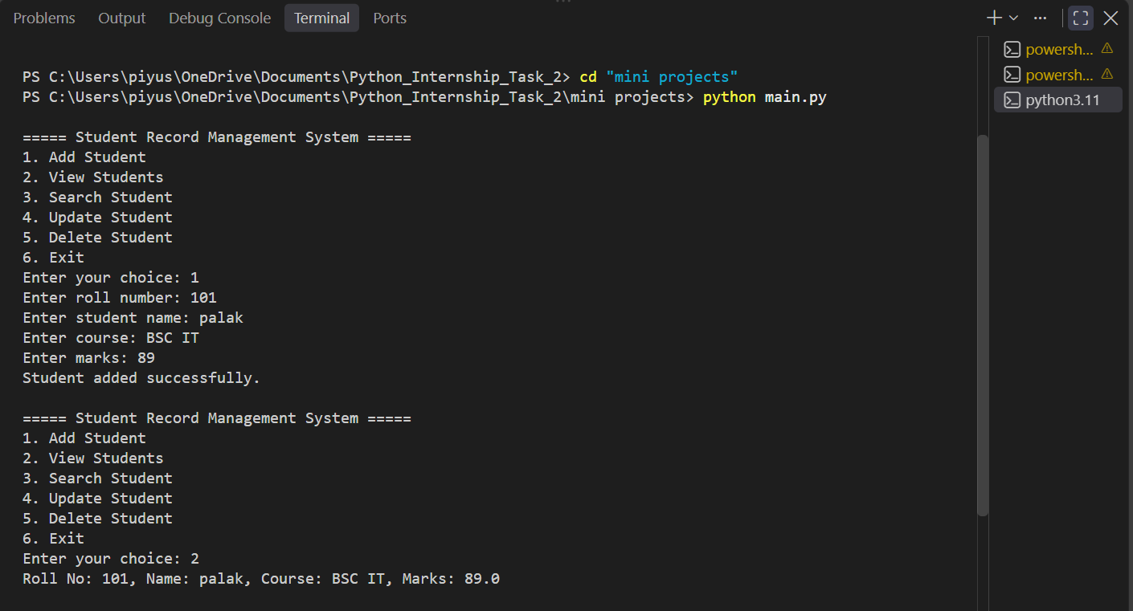
Figure 4: Searching and updating a student
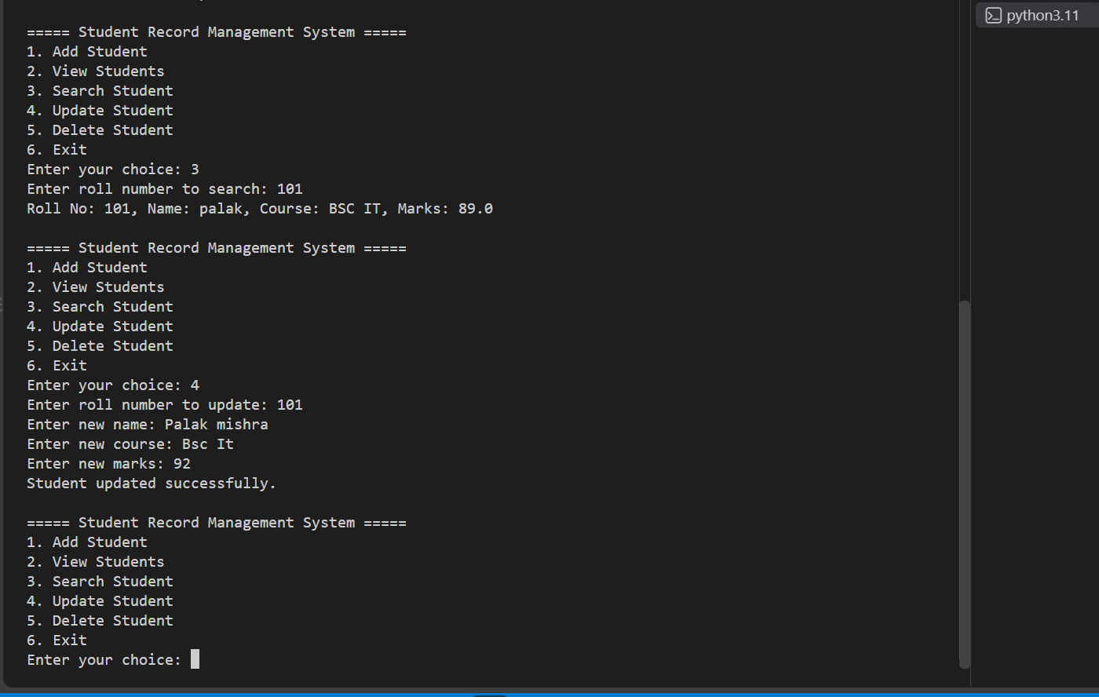
UML Diagram & flowchart 